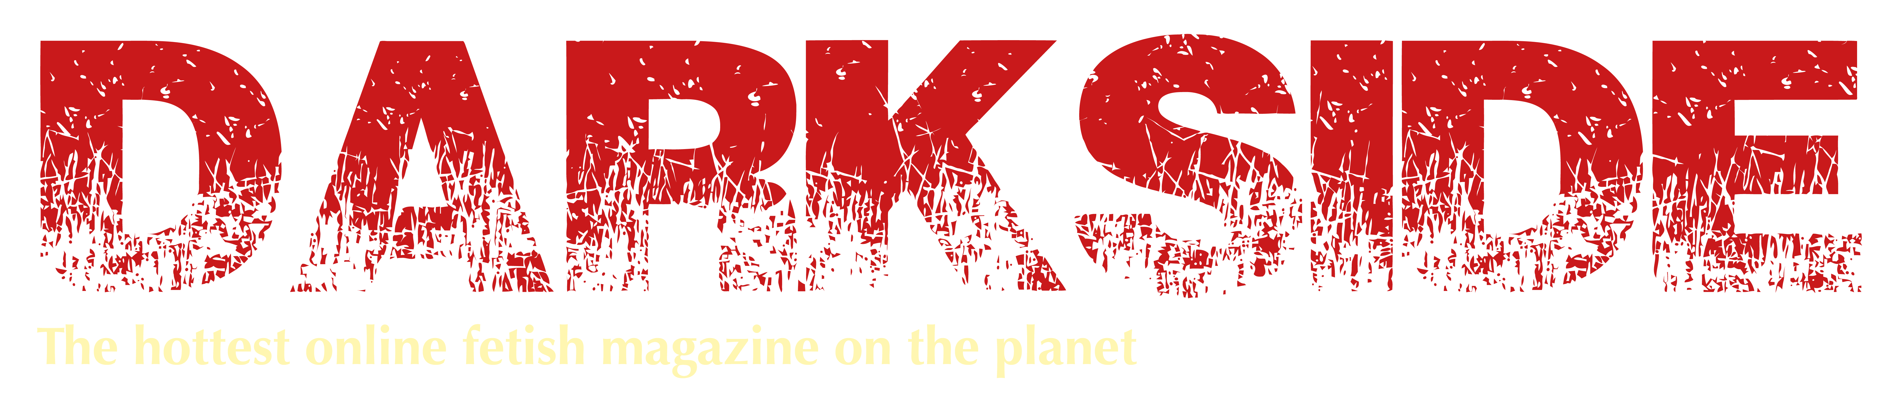

Photo Release Form
Darkside Magazine

I authorise Darkside Magazine, and their legal representatives and assigns, the right and
permission to publish, without charge, photographs taken, as listed below:

File names:

1.) ________________________ 2.) ________________________
3.) ________________________ 4.) ________________________
5.) ________________________ 6.) ________________________
7.) ________________________ 8.) ________________________
9.) ________________________ 10.) _______________________

These photographs may be used in Darkside Magazine and in promotional literature,
advertising, or similar ways which are linked to this publication. I understand that I
retain all copyrights and other rights to my images.

I hereby warrant that I am over eighteen (18) years of age, and am competent to
contract in my own name.

I have read and understand the above:

Signature: _______________________________________________
Printed name: _____________________ Date: ________________
Photographer: __________________________________________

Disclaimer: Above information is held in confidence and is never released or sold.

Please print, scan and email this completed form to paul@darksidemag.net
along with your photographs.

This form should also be accompanied by the Model Release form.

